CS204 Discrete Mathematics, Spring 2018
Recitation #1
Time: 2017.3.8 (Thu) 19:00 ~ 19:30
TA: Donghyun Lim

1. (Rosen 1.1.37)
Construct a truth table for
(p ↔ q) ∨ (¬q ↔ r).

2. (Rosen 1.1.37)
Construct a truth table for
(p ↔ q) ↔ (r ↔ s).

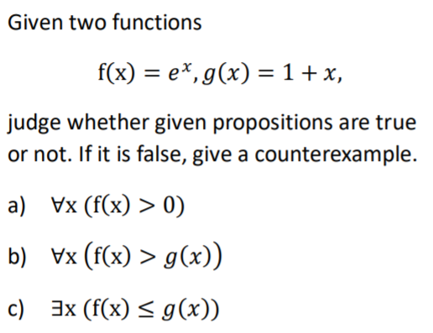
3.
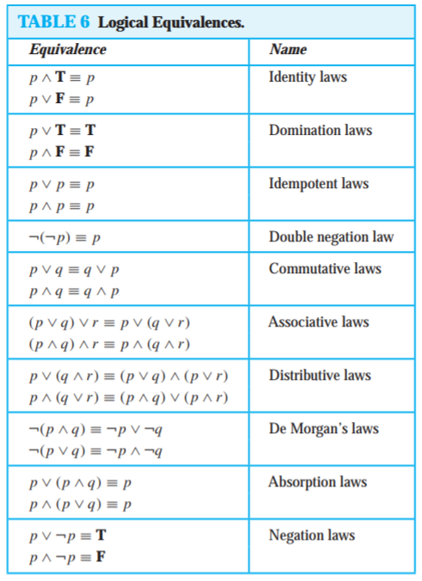

(The domain of discourse is real numbers)

4. (Rosen 1.4.52)
The notation ∃!x P (x) denotes “There exists a unique x such that P (x) is true.” If the domain consists of all integers, what are the truth values of these statements?
a) ∃!x (x > 1)
b) ∃!x ($x^{2}$ = 1)
c) ∃!x (x + 3 = 2x)
d) ∃!x (x = x + 1)

5. (1.3.77)
Show that $\left(p→q\right)≡(¬p∨q)$ using truth table.

6.
Show that p → (q ∧ r) and (p → q) ∧ (p → r) are logically equivalent using logical equivalences (including the one shown in problem 5). Do not use truth table.
Starting from (p → q) ∧ (p → r), apply problem 5 twice, apply distributive law, and apply problem 5 again.

